moveByAngleThrottleAsync 改成 moveByAngleRateThrottle

原函数跟踪：

1. MultirotorRpcLibClient* MultirotorRpcLibClient::moveByAngleThrottleAsync(float pitch, float roll, float throttle, float yaw_rate, float duration, const std::string& vehicle_name)：

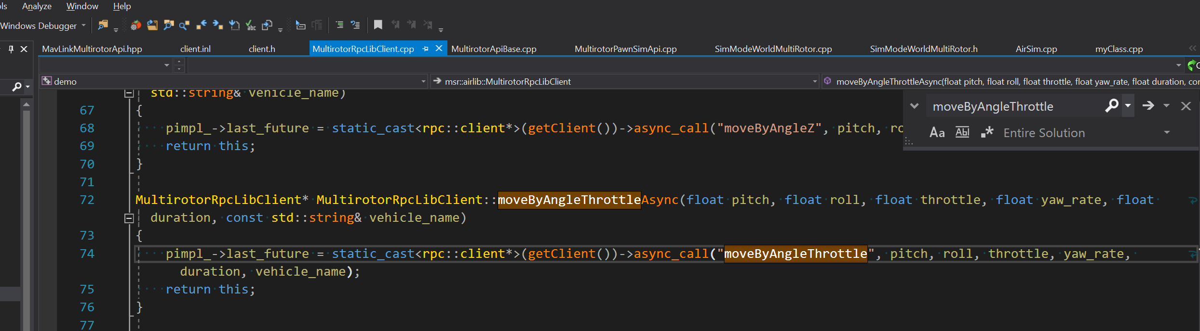

bool MultirotorApiBase::moveByAngleThrottle(float pitch, float roll, float throttle, float yaw_rate, float duration)

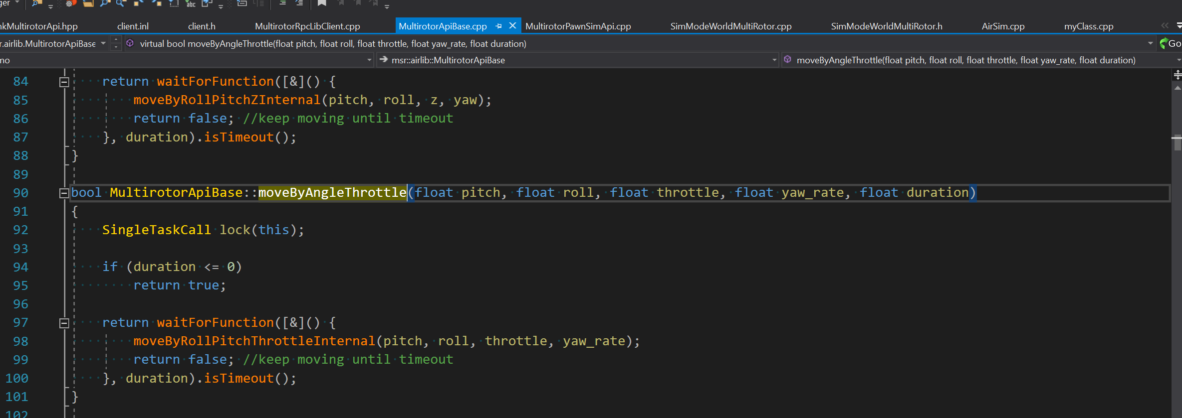

void MultirotorApiBase::moveByRollPitchThrottleInternal(float pitch, float roll, float throttle, float yaw_rate)

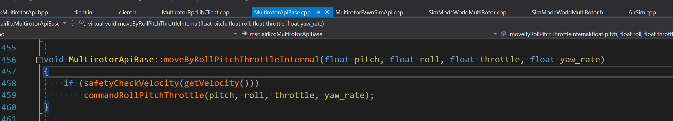

virtual void commandRollPitchThrottle(float pitch, float roll, float throttle, float yaw_rate) override

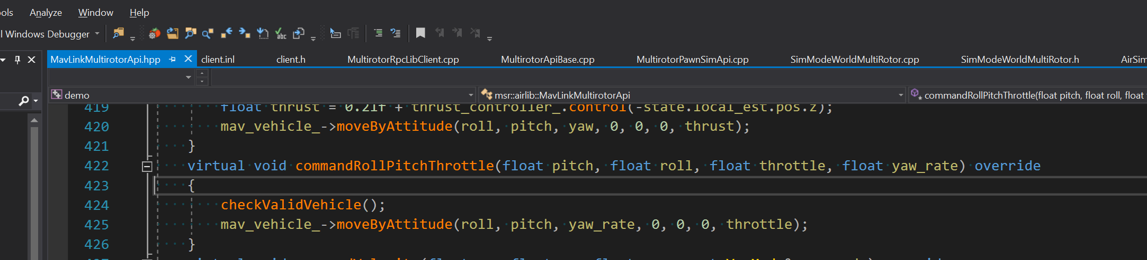

void moveByAttitude(float roll, float pitch, float yaw, float rollRate, float pitchRate, float yawRate, float thrust);

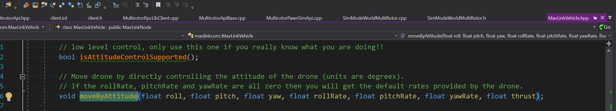

注意，这个函数是在airLib 里面的，具体的原函数在: MavLinkVehicle.cpp 里面(可以通过GitHub搜索), 这个是发送给对应api的

1. 修改 virtual void commandRollPitchThrottle(float pitch, float roll, float throttle, float yaw_rate) override

把198行的angelLevel 改成anglerate 就可以

